**Interactive Report with AT LINE-SELECTION**

***Program theme:*** *In this demo program you will get how to work interactive report with AT LINE-SELECTION Event and declared with the one basic list and maximum of 2 secondary lists output displayed.*

**Step # 1:** Go to SE38 transaction code, create an include programs.

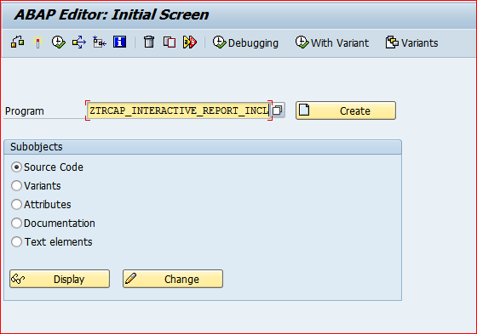

**Step # 2:** Provide the title and select an include program type and click on save button.

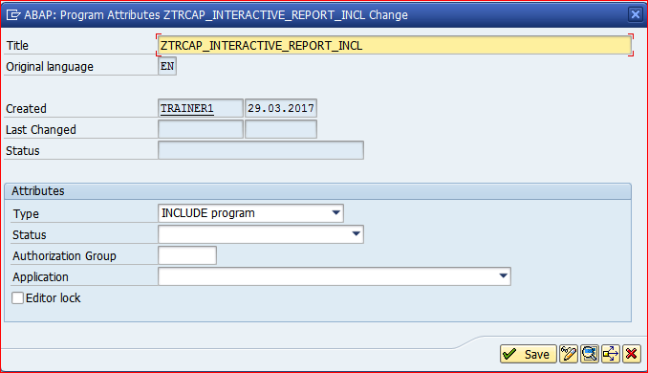

**Step # 3:** Save it in the package.

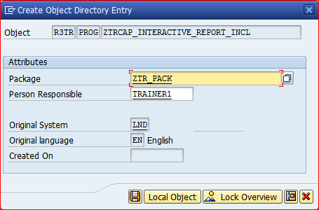

**Step # 4:** Write an include program code logic.

*\*&---------------------------------------------------------------------\**  
*\*&  Include  ZTRCAP_INTERACTIVE_REPORT_INCL*  
*\*&---------------------------------------------------------------------\**  
  
TYPES : BEGIN OF TY_TAB,  *" LOCAL STRS MARA*  
          MATNR TYPE MATNR , *" Material Number*  
          MBRSH TYPE MBRSH,  *" Industry sector*  
          MTART TYPE MTART,  *" Material Group*  
          MEINS TYPE MEINS,  *" Base Unit of Measure*  
        END OF TY_TAB.  
  
DATA :IT_TAB TYPE STANDARD TABLE OF TY_TAB, *"  ITAB*  
      WA_TAB TYPE TY_TAB.  *" WORKAREA*  
  
TYPES : BEGIN OF TY_TAB1,  *" LOCAL STRS MARC*  
          MATNR TYPE MATNR ,  *" Material Number*  
          WERKS TYPE WERKS_D, *" Plant*  
          MEINS TYPE MEINS,   *" Base Unit of Measure*  
        END OF TY_TAB1.  
  
DATA :IT_TAB1 TYPE STANDARD TABLE OF TY_TAB1, *"  ITAB*  
      WA_TAB1 TYPE TY_TAB1.  *" WORKAREA*  
  
TYPES : BEGIN OF TY_TAB2,  *" LOCAL STRS MAKT*  
          MATNR TYPE MATNR ,  *" Material Number*  
          MAKTX TYPE MAKTX,   *" Material description*  
        END OF TY_TAB2.  
  
DATA :IT_TAB2 TYPE STANDARD TABLE OF TY_TAB2, *"  ITAB*  
      WA_TAB2 TYPE TY_TAB2.  *" WORKAREA*  
  
DATA LV_MATNR TYPE MATNR.

**Step # 5:** Go to SE38 transaction code and create an executable program.

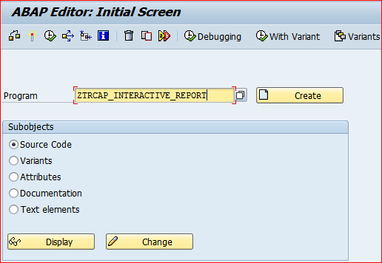

**Step # 6:** Provide the title and select an Executable program type and click on save button.

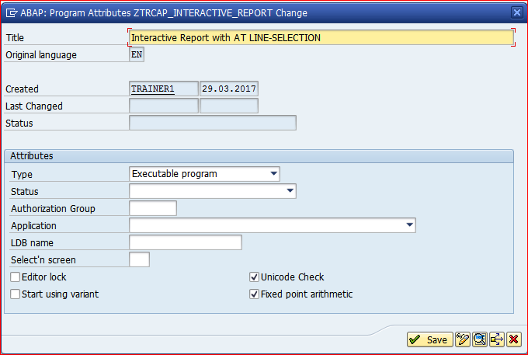

**Step # 7:** Save it in the package.

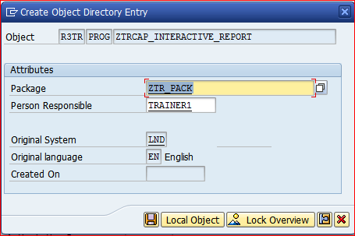

**Step # 8:** Call the Include program and write the executable program code logic.

*\*&---------------------------------------------------------------------\**  
*\*& Report ZTRCAP_INTERACTIVE_REPORT*  
*\*&---------------------------------------------------------------------\**  
*\*&*  
*\*&---------------------------------------------------------------------\**  
REPORT ZTRCAP_INTERACTIVE_REPORT NO STANDARD PAGE HEADING LINE-COUNT 16(2) LINE-SIZE 250 MESSAGE-ID ZTR_MSG1.  
  
INCLUDE ZTR_INT_REPORT_INC13.  
  
SELECT-OPTIONS S_MATNR FOR LV_MATNR.  
  
START-OF-SELECTION.  
  PERFORM  GET_DATA.  
  ULINE.  
  WRITE: 'THE CURRENT LIST INDEX IS No : ', SY-LSIND COLOR COL_POSITIVE.  
  ULINE.  
  
END-OF-SELECTION.  
  
  WRITE: 1 'TABINDEX',  
         13 'MATERIAL NO',  
         30 'IND SECTOR',  
         45 'MAT TYPE',  
         55 'BASE UOM '.  
  ULINE.  
  PERFORM  GET_DISPLAY.  
  
TOP-OF-PAGE.  
  
  WRITE:  50 'MATERIAL MASTER DATA DISPLAYED FROM MARA TABLE' COLOR COL_TOTAL.  
  
END-OF-PAGE.  
  
  WRITE : 'PAGE NO:',SY-PAGNO CENTERED COLOR COL_GROUP.  
  
AT LINE-SELECTION.  
  
  CASE SY-LSIND.  
    WHEN 1.  
      SELECT MATNR  
             WERKS  
         FROM MARC  
        INTO TABLE IT_TAB1  
      WHERE MATNR EQ WA_TAB-MATNR.  
  
      ULINE.  
      WRITE: / 'THE CURRENT LIST INDEX IS No : ', SY-LSIND COLOR COL_POSITIVE.  
      ULINE.  
  
      LOOP AT IT_TAB1 INTO WA_TAB1.  
        WRITE :   SY-TABIX,  
                  WA_TAB1-MATNR HOTSPOT,  
                  WA_TAB1-WERKS.  
        HIDE WA_TAB1-MATNR .  
      ENDLOOP.  
    WHEN 2.  
      SELECT MATNR  
             MAKTX  
          FROM MAKT  
        INTO TABLE IT_TAB2  
      WHERE MATNR EQ WA_TAB1-MATNR.  
      ULINE.  
      WRITE: / 'THE CURRENT LIST INDEX IS No : ', SY-LSIND COLOR COL_POSITIVE.  
      ULINE.  
      LOOP AT IT_TAB2 INTO WA_TAB2.  
        WRITE : / SY-TABIX,  
                  WA_TAB2-MATNR HOTSPOT,  
                  WA_TAB2-MAKTX.  
      ENDLOOP.  
  
  ENDCASE.  
  
TOP-OF-PAGE DURING LINE-SELECTION .  
  
  CASE SY-LSIND.  
    WHEN 1.  
      WRITE 50 'MATERIAL MASTER DATA DISPLAYED FROM MARC TABLE' COLOR COL_TOTAL.  
    WHEN 2.  
      WRITE 50 'MATERIAL MASTER DATA DISPLAYED FROM MAKT TABLE' COLOR COL_TOTAL.  
  
  ENDCASE.  
*\*&---------------------------------------------------------------------\**  
*\*&      Form  GET_DATA*  
*\*&---------------------------------------------------------------------\**  
*\*       text*  
*\*----------------------------------------------------------------------\**  
*\*  -->  p1        text*  
*\*  <--  p2        text*  
*\*----------------------------------------------------------------------\**  
FORM GET_DATA .  
  SELECT MATNR  
           MBRSH  
           MTART  
           MEINS  
      FROM MARA  
      INTO TABLE IT_TAB  
  WHERE MATNR IN S_MATNR.  
ENDFORM.  
*\*&---------------------------------------------------------------------\**  
*\*&      Form  GET_DISPLAY*  
*\*&---------------------------------------------------------------------\**  
*\*       text*  
*\*----------------------------------------------------------------------\**  
*\*  -->  p1        text*  
*\*  <--  p2        text*  
*\*----------------------------------------------------------------------\**  
FORM GET_DISPLAY .  
  LOOP AT IT_TAB INTO WA_TAB.  
    NEW-LINE.  
    WRITE : /  SY-TABIX LEFT-JUSTIFIED,  
             13 WA_TAB-MATNR HOTSPOT,  
             30 WA_TAB-MBRSH,  
             45 WA_TAB-MTART,  
             55 WA_TAB-MEINS.  
    HIDE WA_TAB-MATNR.  
  ENDLOOP.  
ENDFORM.

**Step # 9:** Save and activate the program and execute it (F8).

Provide the material number range in selection screen and execute it.

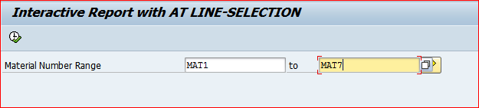

**Step # 10:** Basic list displayed with the range of materials based on the selection inputs.

Double click on any material number to get the First Secondary List (Interactive Report).

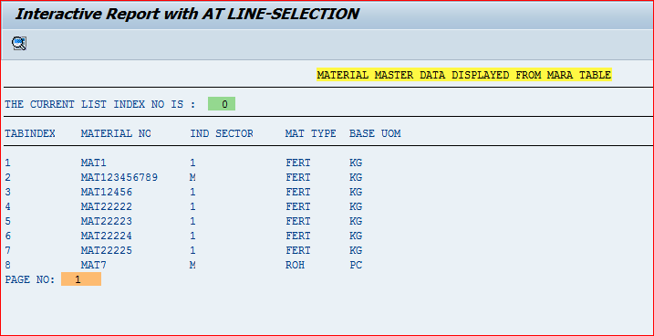

**Step # 11:** First Secondary list displayed with the selected material number.

Double click on any material number to get the Second Secondary List (Interactive Report).

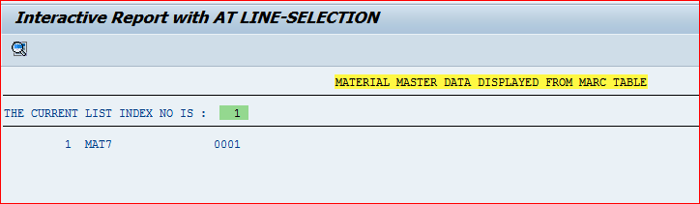

**Step # 12:** Second Secondary list displayed with the selected material number.

